**Name :** Bhanu Pratap Singh

**Course :** b.tech computer science engineering 2nd year

**Roll No. :** 18

**Section :** P

**University Roll Number :**GLA2022-25070107

* Take values of length and breadth of a rectangle from user and check if it is square or not.

**Code**

**import java.util.Scanner;**

**import java.io.*;**

**class assignment{**

**static Scanner sc=new Scanner(System.in);**

**static void qs1(){**

**System.out.print("enter the length :");**

**int a=sc.nextInt();**

**System.out.print("enter the breadth :");**

**int b=sc.nextInt();**

**if(a==b){**

**System.out.println("It is square");**

**}else{**

**System.out.println("It is not the square");**

**}**

**}**

**public static void main(String arg[]){**

**qs1();**

**}**

**}**

**Output**

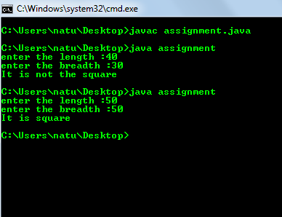

* **Take two int values from user and print greatest among them.**

**Code**

**import java.util.Scanner;**

**import java.io.*;**

**class assignment{**

**static Scanner sc=new Scanner(System.in);**

**static void qs2(){**

**System.out.print("enter First Value :");**

**int num1=sc.nextInt();**

**System.out.print("enter Second value :");**

**int num2=sc.nextInt();**

**if (num1 == num2)**

**System.out.println ("both are equal");**

**else if (num1 > num2)**

**System.out.println (num1 + " is greater");**

**else**

**System.out.println (num2 + " is greater");**

**}**

**public static void main(String arg[]){**

**qs1();**

**}**

**}**

**Output**

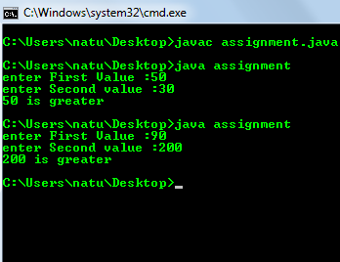

* A shop will give discount of 10% if the cost of purchased quantity is more than 1000.
* Ask user for quantity
* Suppose, one unit will cost 100.
* Judge and print total cost for user**.**

**Code**

**import java.util.Scanner;**

**import java.io.*;**

**class assignment{**

**static Scanner sc=new Scanner(System.in);**

**static void qs3(){**

**System.out.println("Enter the quantity: ");**

**double n = sc.nextDouble();**

**if (n>1000) {**

**System.out.println("The total cost = "+(n-(n/100*10)));**

**}**

**else{**

**System.out.println("The total cost = "+n);**

**}**

**}**

**public static void main(String arg[]){**

**qs3();**

**}**

**}**

**Output**

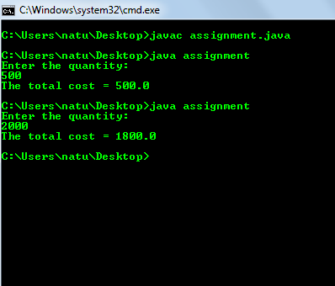

* A company decided to give bonus of 5% to employee if his/her year of service is more than 5 years.Ask user for their salary and year of service and print the net bonus amount.

**Code**

**import java.util.Scanner;**

**import java.io.*;**

**class assignment{**

**static Scanner sc=new Scanner(System.in);**

**static void qs4(){**

**int year;**

**int sal;**

**double d;**

**System.out.print("Enter total Years of services : ");**

**year=sc.nextInt();**

**if(year>5){**

**System.out.print("Congrats..YES..! your total year of services more than 5 years\n\nPlease Enter your salary..> ");**

**sal=sc.nextInt();**

**System.out.println("YOUR SALARY IS : "+sal);**

**System.out.println("YOUR 5% BONUS IS :"+sal*0.05);**

**System.out.println("YOUR NET BONUS WITH SALARY IS :"+(sal+(sal*0.05)));**

**}**

**else{**

**System.out.println("NO BONUS..");**

**}**

**}**

**public static void main(String arg[]){**

**qs4();**

**}**

**}**

**OutPut**

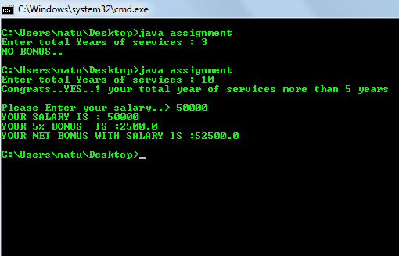

* A school has following rules for grading system:

a. Below 25 - F

b. 25 to 45 - E

c. 45 to 50 - D

d. 50 to 60 - C

e. 60 to 80 - B

f. Above 80 - A

Ask user to enter marks and print the corresponding grade.

**Code**

**import java.util.Scanner;**

**import java.io.*;**

**class assignment{**

**static Scanner sc=new Scanner(System.in);**

**static void qs5(){**

**System.out.print("Enter your marks : ");**

**int x = sc.nextInt();**

**if(x<25){**

**System.out.println("F");**

**}**

**else if((x>=25)&&(x<45)){**

**System.out.println("E");**

**}**

**else if((x>=45)&&(x<50)){**

**System.out.println("D");**

**}**

**else if((x>=50)&&(x<60)){**

**System.out.println("C");**

**}**

**else if((x>=60)&&(x<80)){**

**System.out.println("B");**

**}**

**else if((x>=80)&&(x<=100)){**

**System.out.println("A");**

**}**

**else{**

**System.out.println("Not correct marks");**

**}**

**}**

**public static void main(String arg[]){**

**qs5();**

**}**

**}**

**OutPut**

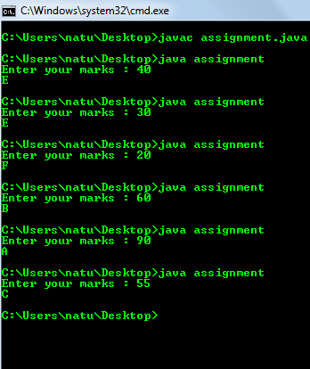

* Take input of age of 3 people by user and determine oldest and youngest among them.

Code

**import java.util.Scanner;**

**import java.io.*;**

**class assignment{**

**static Scanner sc=new Scanner(System.in);**

**static void qs6(){**

**int age1,age2,age3,max,min;**

**System.out.print("Enter the age of First Person: ");**

**age1=sc.nextInt();**

**System.out.print("Enter the age of Second Person: ");**

**age2=sc.nextInt();**

**System.out.print("Enter the age of Third Person: ");**

**age3=sc.nextInt();**

**if(age1>age2 && age1>age3){**

**System.out.println("First Person is the Oldest.");**

**}else if(age2>age1 && age2>age3){**

**System.out.println("Second Person is the Oldest.");**

**}else if(age3>age1 && age3>age2){**

**System.out.println("Third Person is the Oldest.");**

**}else{**

**System.out.println("All have equal ages.");**

**// System.exit(0);**

**}**

**if(age1<age2 && age1<age3){**

**System.out.println("First Person is the Youngest.");**

**}else if(age2<age1 && age2<age3){**

**System.out.println("Second Person is the Youngest.");**

**}else if(age3<age1 && age3<age2){**

**System.out.println("Third Person is the Youngest.");**

**}**

**}**

**public static void main(String arg[]){**

**qs6();**

**}**

**}**

**Output**

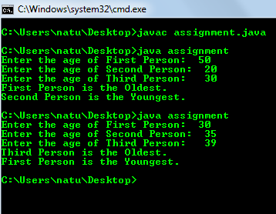

* Write a program to print absolute vlaue of a number entered by user. E.g.-

INPUT: 1 OUTPUT: 1

INPUT: -1 OUTPUT: 1

**Code**

**import java.util.Scanner;**

**import java.io.*;**

**class assignment{**

**static Scanner sc=new Scanner(System.in);**

**static void qs7(){**

**System.out.print("Enter Value : ");**

**int x=sc.nextInt();**

**System.out.printf( "Absolute Value of x : " + Math.abs(x) );**

**}**

**public static void main(String arg[]){**

**qs7();**

**}**

**}**

**OutPut**

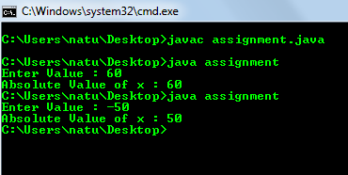

* A student will not be allowed to sit in exam if his/her attendence is less than 75%.
* Take following input from user
* Number of classes held
* Number of classes attended.
* And print
* percentage of class attended
* Is student is allowed to sit in exam or not.

**Code**

**import java.util.Scanner;**

**import java.io.*;**

**class assignment{**

**static Scanner sc=new Scanner(System.in);**

**static void qs8(){**

**System.out.print("Number of classes held : ");**

**int x=sc.nextInt();**

**System.out.print("Number of classes attended : ");**

**int y=sc.nextInt();**

**int pf=y*100/x;**

**System.out.println(pf);**

**if(pf>=75){**

**System.out.println("The student is allowed to sit in the exam hall : "+pf);**

**}else{**

**System.out.println("The student is not allowed to sit in the exam hall : "+pf);**

**}**

**}**

**public static void main(String arg[]){**

**qs8();**

**}**

**}**

**Output**

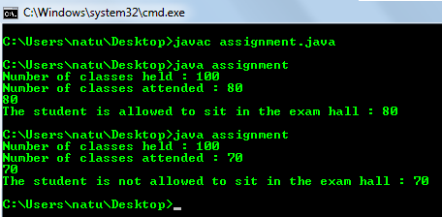

* Modify the above question to allow student to sit if he/she has medical cause. Ask user if he/she has medical cause or not ( 'Y' or 'N' ) and print accordingly.

**Code**

**import java.util.Scanner;**

**import java.io.*;**

**class assignment{**

**static Scanner sc=new Scanner(System.in);**

**static void qs9(){**

**System.out.print("Medical cause or not ( 'Y' or 'N' ) : ");**

**String z=sc.nextLine();**

**System.out.print("Number of classes held : ");**

**int x=sc.nextInt();**

**System.out.print("Number of classes attended : ");**

**int y=sc.nextInt();**

**int pf=y*100/x;**

**if(pf>=75 && z.equals("y")){**

**System.out.println("The student is allowed to sit in the exam hall : "+pf);**

**}else if(pf>=75 && z.equals("n")){**

**System.out.println("The student is allowed to sit in the exam hall : "+pf);**

**}**

**else{**

**System.out.println("The student is not allowed to sit in the exam hall : "+pf);**

**}**

**}**

**public static void main(String arg[]){**

**qs9();**

**}**

**}**

**OutPut**

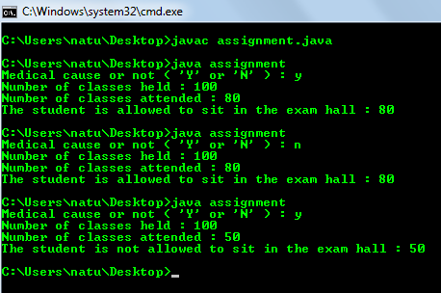

* If x = 2 y = 5 z = 0 then find values of the following expressions:

a. x == 2

b. x != 5

c. x != 5 && y >= 5

d. z != 0 || x == 2

e. !(y < 10)

**Code**

**import java.util.Scanner;**

**import java.io.*;**

**class assignment{**

**static Scanner sc=new Scanner(System.in);**

**static void qs10(){**

**int x=2;**

**int y=5;**

**int z=0;**

**System.out.println(x==2);**

**System.out.println(x!=5);**

**System.out.println(x!=5 && y>=5);**

**System.out.println(!(y<10));**

**}**

**public static void main(String arg[]){**

**qs10();**

**}**

**}**

**Output**

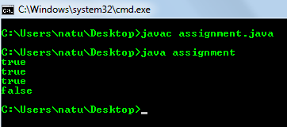

* Write a program to check whether a entered character is lowercase ( a to z ) or uppercase ( A to Z ).

**Code**

**import java.util.Scanner;**

**import java.io.*;**

**class assignment{**

**static Scanner sc=new Scanner(System.in);**

**static void qs11(){**

**char ch;**

**System.out.print("Enter the character ");**

**ch=sc.next().charAt(0);**

**if(ch>='A' && ch<='Z'){**

**System.out.println(ch+" is an upper case letter ");**

**}**

**else if(ch>='a' && ch<='z'){**

**System.out.println(ch+" is a lower case letter ");**

**}**

**else{**

**System.out.println(ch+" is not a Alphabets ");**

**}**

**}**

**public static void main(String arg[]){**

**qs11();**

**}**

**}**

**OutPut**

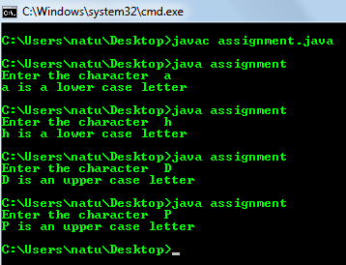

* Write a program to check if a year is leap year or not.If a year is divisible by 4 then it is leap year but if the year is century year like 2000, 1900, 2100 then it must be divisible by 400.

**Code**

**import java.util.Scanner;**

**import java.io.*;**

**class assignment{**

**static Scanner sc=new Scanner(System.in);**

**static void qs12(){**

**System.out.print("Enter an Year : ");**

**int year= sc.nextInt();**

**if (year % 4 == 0 && year % 100!= 0 || year%400 == 0){**

**System.out.println("Specified year is a leap year");**

**}else{**

**System.out.println("Specified year is not a leap year");**

**}**

**}**

**public static void main(String arg[]){**

**qs12();**

**}**

**}**

**OutPut**

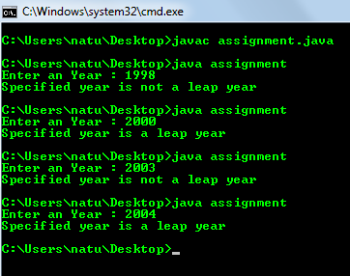

* Ask user to enter age, sex ( M or F ), marital status ( Y or N ) and then using following rules print their place of service.
* if employee is female, then she will work only in urban areas.
* if employee is a male and age is in between 20 to 40 then he may work in anywhere
* if employee is male and age is in between 40 t0 60 then he will work in urban areas only.
* And any other input of age should print "ERROR".

**Code**

**import java.util.Scanner;**

**import java.io.*;**

**class assignment{**

**static Scanner sc=new Scanner(System.in);**

**static void qs13(){**

**System.out.print("Enter age :");**

**int age = sc.nextInt();**

**System.out.print("Enter sex: M/F");**

**int sex = sc.next().charAt(0);**

**if(sex == 'F') {**

**System.out.println("You will work only in urban areas");**

**}**

**if(sex == 'M') {**

**if((age >= 20) && (age < 40)) {**

**System.out.println("You may work anywhere");**

**}**

**else if((age >= 40) && (age < 60)) {**

**System.out.println("You will work only in urban areas");**

**}**

**else {**

**System.out.println("ERROR");**

**}**

**}**

**}**

**public static void main(String arg[]){**

**qs13();**

**}**

**}**

**Output**

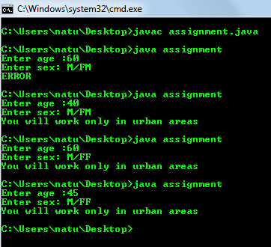

* A 4 digit number is entered through keyboard. Write a program to print a new number with digits reversed as of orignal one. E.g.-

**INPUT : 1234 OUTPUT : 4321 , INPUT : 5982 OUTPUT : 2895**

**Code**

**import java.util.Scanner;**

**import java.io.*;**

**class assignment{**

**static Scanner sc=new Scanner(System.in);**

**static void qs14(){**

**int reverse = 0;**

**System.out.print("Enter Number : ");**

**int num=sc.nextInt();**

**while(num != 0){**

**int remainder = num % 10;**

**reverse = reverse * 10 + remainder;**

**num = num/10;**

**}**

**System.out.println("The reverse of the given number is: " + reverse);**

**}**

**public static void main(String arg[]){**

**qs14();**

**}**

**}**

**OutPut**

